|  |  |
| --- | --- |
| **Use Case Textual Description** | |
| **UC-ID** | UC-01 |
| **Name** | Book a facility |
| **Description** | Making a facility booking is an important function in the system. Is allows the user to pay their booking fees as well as membership fees on the internet |
| **Actor(s)** | User |
| **Main Scenario** | Step 1: user login to book one of any facility available  Step 2: the user get information on the facility he/she is trying to book  Step 3: the user will then book a time slot for that facility if it is available  Step 4: payment will be made after the confirmation of the booking  Step 5: a summary of the booking will\be displayed and system will update |
| **Alternate Flow** |  |

Use case

|  |  |
| --- | --- |
| **Use Case Textual Description** | |
| **UC-ID** | UC-02 |
| **Name** | Admin accessing and update system info |
| **Description** | Admin is able to change the rates charges to each of the facility, update, view and display notice on the users main menu (events/news) . Most importantly the admin can create, delete or update events and facility. |
| **Actor(s)** | Admin and system |
| **Main Scenario** | Step 1: Admin wishes to add new facility and update currently information  Step 2: After adding new facility, the admin then edit the rates of each facility  Step 3: The system will then be updated and the new rates will be applied after a specific time/period  Step 4: Then Admin then update the notice board in the system to notify the users all the changes its made |
| **Alternate Flow** |  |

Sequence diagram 1

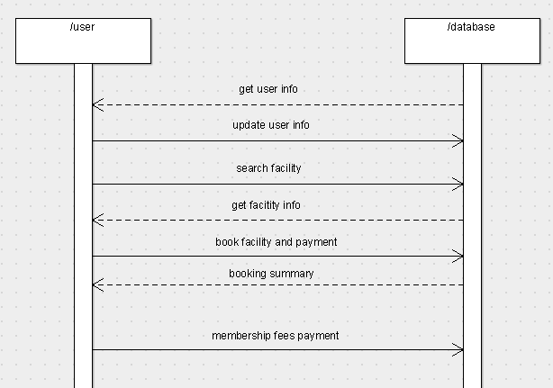

Class: User

* User’s particulars
* Edit info
* View booking
* Book a facility
* Membership payment
* Personal message/mail

Class: Database

* Facility
* View facility availability
* View events and news

Sequence diagram 2

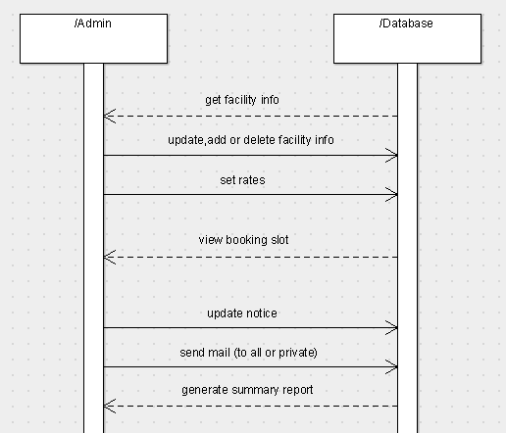

Class: Admin

* Get facility info
* Add, delete or update facility info
* Set rates
* View all booking slots
* Update notice board
* Send mail to all members or private messages

Class: database

* Facility info
* Events and news info
* Rates charges
* Summary report